Exercise: Simple Data Plotting

The aim of this exercise is to **plot** TV Ads vs Sales based on the Advertisement dataset which should look similar to the graph given below.

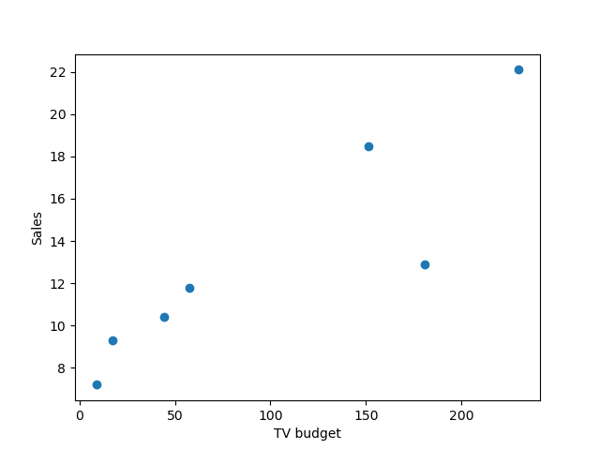

Instructions:

* Read the Advertisement data and view the top rows of the dataframe to get an understanding of the data and the columns.
* Select the first 7 observations and the columns TV and sales to make a new data frame.
* Create a scatter plot of the new data frame TV budget vs sales .

Hints:

**The following are direct links to documentation for some of the functions used in this exercise. As always, if you are unsure how to use a function, refer to its documentation.**

[**pd.read_csv(*filename*)**](https://pandas.pydata.org/pandas-docs/stable/reference/api/pandas.read_csv.html)

Returns a pandas dataframe containing the data and labels from the file data

[**df.iloc[]**](https://pandas.pydata.org/pandas-docs/stable/reference/api/pandas.DataFrame.iloc.html?highlight=iloc#pandas.DataFrame.iloc)

Returns a subset of the dataframe that is contained in the row range passed as the argument

[**df.head()**](https://pandas.pydata.org/pandas-docs/stable/reference/api/pandas.DataFrame.head.html?highlight=head#pandas.DataFrame.head)

Returns the first 5 rows of the dataframe with the column names

[**plt.scatter()**](https://matplotlib.org/3.2.2/api/_as_gen/matplotlib.pyplot.scatter.html)

A scatter plot of *y* vs. *x* with varying marker size and/or color

[**plt.xlabel()**](https://matplotlib.org/stable/api/_as_gen/matplotlib.pyplot.xlabel.html)

This is used to specify the text to be displayed as the label for the x-axis

[**plt.ylabel()**](https://matplotlib.org/stable/api/_as_gen/matplotlib.pyplot.ylabel.html)

This is used to specify the text to be displayed as the label for the y-axis

[**plt.title()**](https://matplotlib.org/stable/api/_as_gen/matplotlib.pyplot.title.html)

This is used to specify the title to be displayed for the plot